AUTUMN/WINTER MENU 2023-2024
 | MONDAY | TUESDAY | WEDNESDAY | THURSDAY | FRIDAY
Breakfast | CEREALS OR TOAST  Served with: Milk or Water  Allergens: Milk, Wheat | CEREALS OR TOAST  Served with: Milk or Water  Allergens: Milk, Wheat | CEREALS OR TOAST  Served with: Milk or Water  Allergens: Milk, Wheat | CEREALS OR TOAST  Served with: Milk or Water  Allergens: Milk, Wheat | CEREALS OR TOAST  Served with: Milk or Water  Allergens: Milk, Wheat
Snack | PINEAPPLE SLICES | STRAWBERRIES | BANANA SLICES | ORANGES WEDGES | HONEYDEW MELON
Lunch | Tuna & pasta bake  Allergens: Wheat, Fish | Jollof rice, roast chicken & Coleslaw  Allergens: Egg | Creamy spaghetti green peas & cod fish  Allergens: Fish, Milk | Shepherd’s pie, mixed vegetables & cucumber salad  Allergens: Wheat, Milk, Egg | Roast potatoes, meat loaf and green peas  Allergens: Wheat, Milk, Egg
Dessert | Strawberry Semolina  Allergens: Milk, Wheat | Banana Custard  Allergens: Wheat, Milk | Peach Cobbler & Ice cream  Allergens: Milk, Wheat | Fruit Jelly  Allergens: N/A | Natural Yogurts  Allergens: Milk
Snack | CHEESE AND CUCUMBER STICKS  Allergens: Milk | BREADSTICKS WITH CHEESE DIP | HOMEMADE RAISINS & OAT COOKIES | RICE CAKES AND WITH STRAWBERRY JAM (SUGAR FREE) | ORANGE WEDGES
Tea | Tuna bagel melt  Allergens: Fish, Wheat, Milk | Egg Sandwiches  Allergens: Milk, Egg, Wheat | Crumpets with cheese  Allergens: Wheat, Milk | Beans on Toast  Allergens: Milk, Wheat, Soya | Homemade vegetables soup & bread  Allergens: Wheat, Soya
WEEK 4
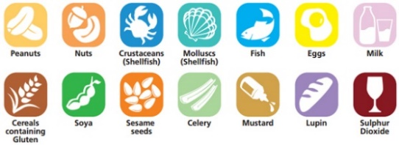
ALLERGENS

