WINTER MENU 2023-2024
 | MONDAY | TUESDAY | WEDNESDAY | THURSDAY | FRIDAY
Breakfast | CEREALS OR TOAST  Served with: Milk or Water  Allergens: Wheat, Milk | CEREALS OR TOAST  Served with: Milk or Water  Allergens: Wheat, Milk | CEREALS OR TOAST  Served with: Milk or Water  Allergens: Wheat, Milk | CEREALS OR TOAST  Served with: Milk or Water  Allergens: Wheat, Milk | CEREALS OR TOAST  Served with: Milk or Water  Allergens: Wheat, Milk
Snack | SLICED APPLES | ORANGES WEDGES | SLICED BANANA | PEACH SLICES | APPLES SLICES
Lunch | Homemade vegetable soup & naan bread  Allergens: Wheat, Milk, Soya | Tagliatelle Bolognese & baby spinach  Allergens: Wheat, Milk, Egg | Roast potatoes, fish bites & garden peas/carrots  Allergens: Fish, Wheat | Spaghetti Neapolitan with cheddar cheese & mixed vegetables  Allergens: Wheat, Milk | Chicken & kidney beans pilau with coleslaw  Allergens: Egg
Dessert | Rice Pudding  Allergens: Milk | Fruit yogurts  Allergens: Milk | Forest fruit crumble & custard  Allergens: Wheat, Milk | Fresh Fruit salad  Allergens: N/A | Mini Carrot cake  Allergens: Wheat, Milk, Egg
Snack | Oranges | Seasonal Mixed Fruits | Melon slices | Carrot and cucumber sticks | Bread sticks
Tea | Tuna and sweetcorn sandwiches  Allergens: Wheat, Fish, Egg | Scrambled eggs with peppers on toast  Allergens: Wheat, Egg, Soya | Mixed bean chilli with pitta soldiers  Allergens: Wheat, Fish | Beans on toast  Allergens: Fish, Wheat | Homemade Leek & potato soup  Allergens: Milk
WEEK 3
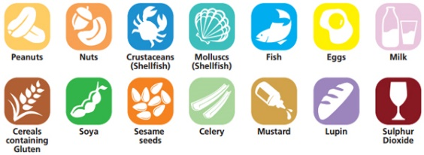
ALLERGENS

