AUTUMN/WINTER MENU 2023-2024
 | MONDAY | TUESDAY | WEDNESDAY | THURSDAY | FRIDAY
Breakfast | CEREALS OR WEETABIX  Served with: Milk or Water  Allergens: Milk, Wheat | CEREALS OR TOAST  Served with: Milk or Water  Allergens: Milk, Wheat | CEREALS OR WEETABIX  Served with: Milk or Water  Allergens: Milk, Wheat | CEREALS OR TOAST  Served with: Milk or Water  Allergens: Milk, Wheat | CEREALS OR WEETABIX  Served with: Milk or Water  Allergens: Milk, Wheat
Snack | SELECTION OF FRUITS | STRAWBERRIES | CHEESE BATONS | SELECTION OF FRUITS | APPLE SLICES
Lunch | Vegetarian lasagne with carrots & garden peas  Allergens: Wheat, Milk | Potato fish pie with steamed carrot  Allergens: Milk, Fish | Vegetarian & chicken stir fry noodles.  Allergens: Soya, Wheat | Vegetable curry with rice & broccoli  Allergens N/A | Potato wedges, fish fingers & garden peas  Allergens: Fish, Wheat
Dessert | Semolina  Allergens: Milk, Wheat | Yogurt & peach slices  Allergens Milk | Chocolate custard  Allergens: Milk | Fruit crumble  Allergens: Wheat, Milk | Orange sponge cake & custard  Allergens: Wheat, Egg, Milk
Snack | Rice cakes and cream cheese  Allergens Milk | Fruit Platter | Bread sticks with cheesed dip  Allergens: Milk, Wheat | Apple slices & raisins | Carrot & cucumber sticks
Tea | Mixed beans chilli with pitta fingers  Allergens: Wheat | Butternut squash & lentil soup  Allergens: N/A | Scrambled eggs on toast with roasted bell peppers  Allergens: Egg, Wheat | Leek & potato soup with bread fingers  Allergens: Milk, Wheat | Selection of sandwiches  Allergens: Wheat, Milk, Egg
WEEK 1
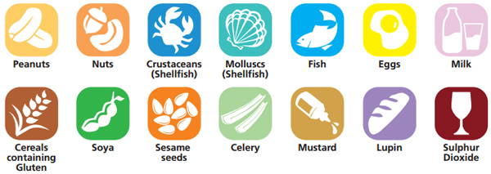
ALLERGENS

