AUTUMN/WINTER MENU 2023-2024
 | MONDAY | TUESDAY | WEDNESDAY | THURSDAY | FRIDAY
Breakfast | CEREALS OR TOAST  Served with: Milk or Water  Allergens: Milk, Wheat | CEREALS OR WEETABIX  Served with: Milk or Water  Allergens: Milk, Wheat | CEREALS OR TOAST  Served with: Milk or Water  Allergens: Milk, Wheat | CEREALS OR WEETABIX  Served with: Milk or Water  Allergens: Milk, Wheat | CEREALS OR TOAST  Served with: Milk or Water  Allergens: Milk, Wheat
Snack | SLICE APPLE | BANANA SLICES | VEGETABLE STICKS | PINEAPPLE SHAPES | ORANGE WEDGES
Lunch | Mac & cheese, broccoli & carrots  Allergens: Milk, Wheat | Chilli con carne with rice  Allergens: N/A | Fish curry with mash potato & steam carrots  Allergens: Fish, Egg, Milk | Chicken fricassee with rice & green peas  Allergens: Milk | Jacket potato, beans & cheese  Allergens: Fish, Wheat
Dessert | Angel Delight  Allergens: Milk | Fruit Platter  Allergens: N/A | Apple crumble & custard  Allergens:  Egg, Wheat, Milk | Rice pudding with Raspberry compote  Allergens: Milk, Egg | Orange sponge cake  Allergens: Milk, Wheat, Egg
Snack | Honey dew melon  Allergens: N/A | Banana  Allergens: N/A | Cucumber sticks & cream cheese.  Allergens: Soya, Wheat  Milk | Oranges  Allergens: N/A | Carrots sticks  Allergens: N/A
Tea | Squash & lentil soup with toast soldiers  Allergens: Wheat, Milk, Egg | Pitta pockets with grated cheddar & tomatoes  Allergens:  Wheat, Milk | Egg & sweetcorn sandwiches  Allergens: Egg, Milk, Wheat, Soya | Leek & potato soup bread & butter  Allergens: Wheat, Egg, Soya, Milk | Tuna Melts  Allergens: Milk, Wheat, Soya, fish
WEEK 2
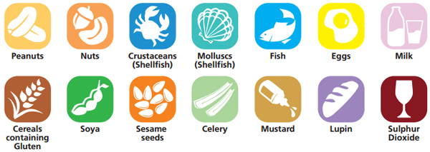
ALLERGENS

